Types of Stands
Island

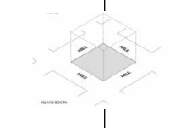 | Island Stands – An Island stand is exposed on all four sides. Any walls must comply with the 50% rule (if applicable – please see 3.3 OPEN FRONTAGES/ SOLID WALLS). Enclosing walls (i.e. directly onto the aisle) are restricted to up to 50% of the length of the side of the booth and should be made to look interesting from the aisle and neighbouring booths.  * You may display double-sided signs, logos and graphics if you have gained permission from Organiser.

